SRS OF MPCC

**MPCC_1: Client-Server Connection: A connection will be established between the Client and Server, it will be the initial step to initiate the chat.**

1. The connection has to be established between the Client and Server.

**MPCC_2: Client Registration: A new user has to register first, in order to use the MPCC. A new entry is to be created in the registered Users file.**

1. Whenever the new User enters into the MPCC, The User needs to first get registered and then the User will be considered for further processing.
2. New User have to submit all the required details like Name, Age, Gender, contact number, email-id, phone no, password to get registered in MPCC.

**MPCC_3: Client Authentication: Existing User Session Connection has to be Authenticated.**

1. The client submit the user name and password to the server.
2. The server validates the credentials and, if successful, return to the requested resource.

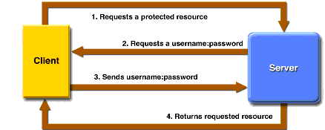

**MPCC_4: Active Client Session: A Session with the active Client has to be maintained, in case of connection loss the client has to reconnect to the server with a new session.**

1. When the client reconnect to the server, the server connects the client to a new session instead of the original session.
2. However, when we check the server, it says that the original session is still active and didn't enter a disconnected state.
3. When attempting to reconnect to a disconnected session, users are required to specify their login credentials.
4. After the server validates them, the server reconnect them to the disconnected session.
5. If the session is hosted on a server that is part of a Server configuration, the user is routed to his or her session without any indication that the session is on a Server.

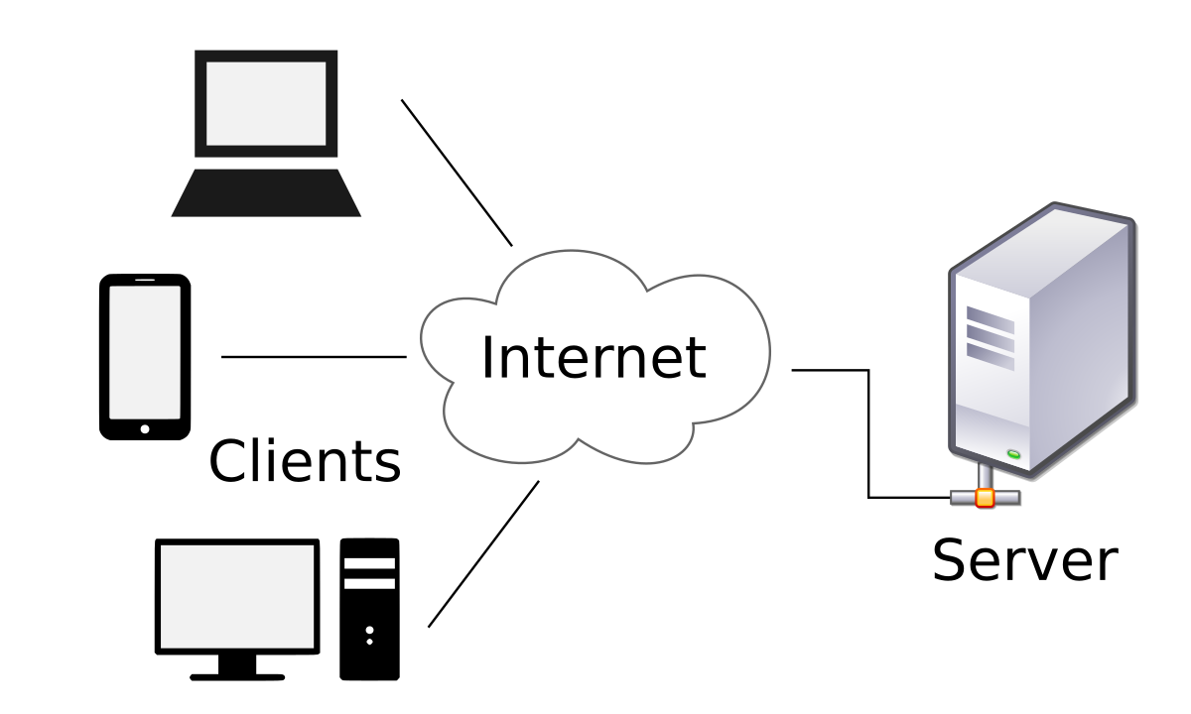

**MPCC_5: Concurrent Server to Serve Multiple Clients: A concurrent Server has to be maintained in order to serve Multiple Client Connection/ Chat Requests. Multiple client requests maintenance to be done**

* Concurrent server means a server has a capability of handling multiple clients at the same time parallelly.
* In this requirement, we have to maintain a concurrent server to serve multiple client connection/chat request.

**MPCC_6: Message Broadcast: Message sent by one client has to be Broadcasted to all the Connected Users along with their user-id to identify (what message is written by which user).**

* Broadcasting means sending a message to all connected clients.
* We can send the message to all the connected clients.
* In this requirement, if an active user send any message that has to be broadcasted to all other active users along with their user-id to maintain a clarity like which user have send which message.

**MPCC_7:** **Registered Users: a file having the list of registered users has to be maintained.**

1. We need to maintain a file which contains the list of registered users in MPCC.

**MPCC_8:** **Session Termination: Session has to be terminated once the client is disconnected.**

1. As the session gets completed client has to be disconnected.

**MPCC_9: IP Mapping to Users: Name of the user is displayed by mapping the IP Address to user-id**

* After registering, user’s name will be in registered in user’s file.
* The name of each user will be displayed mapping IP address.
* **Example:** Desktop and Mobile (it will be verified using serial number).

**MPCC_10:** **Encryption: Encryption has to be used for sending user-id, password and messages in order to attain security in the chat system.**

* Encryption is method by which information is converted into a secret code that hides the information true meaning.
* It is used to protect the data.
* Here sending user-id ,password and message in encrypted form, for security purpose in chat system.

**MPCC_11:** **Decryption: Decryption has to be used for receiving user-id, password and messages in order to attain security in the chat system.**

* Decryption is the process that transforms encrypted information into its original format.

To do this parties with private conversation use an encryption scheme called an algorithm and

the keys to encrypt and decrypt messages.

Absent the tools for decryption, someone who intercepts our messages cannot access our documents in any readable format.

User-id, password, message

Import data

ENCRYPTION

Encrypt using algorithm

Encrypted user-id password,messages

Import data from encrypted

DECRYPTED

Decrypt using algorithm

Decrypted user-id,password,messages

**MPCC_12:"Should include debug log messages with atleast 4 levels (FATA, INFO, WARNING, DEBUG)**

**A)** **FATAL**: Designates every severe errors events that will presumably lead the application to abort.

**INFO:** Designates informational messages that highlight the progress of the application at coarse grained level.

**WARNING:** Designates potentially harmful situations.

**DEBUG:** Designates fine-grained informational events that are most useful to debug an application.